**St**

**GRADE 2S/T ST. PETER’S COLLEGE COLOMBO – 04 01 HOUR**

**SECOND TERM TEST – 2016**

**ENGLISH LANGUAGE**

**NAME:…………………………..……………....CLASS:………..NO:………**

1. **Join the numbers, pictures and words.**

|  |  |  |
| --- | --- | --- |
| No. | Pictures | Words |
| 1 |  | Three |
| 2 |  | Two |
| 3 |  | One |
| 4 |  | Five |
| 5 |  | Four |

(15 Marks)

(02)**Fill in the blanks using am, is, are.**

1. I …………………….. a boy.
2. The birds ……………………. flying.
3. The elephant ……………………… big.
4. My books ……………………… new.
5. The chair ……………………….. broken.
6. Marks)

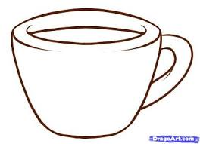**(03)Match.**

Cup

House

Flower

Tree

Mango

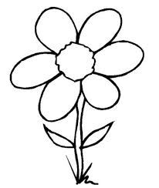

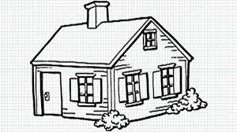

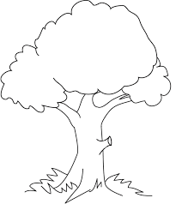

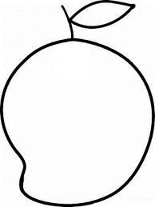

(10 Marks)

(04)**Write a or an.**

1. ………………. elephant

2. ………………. Engine

3. ………………. Rabbit

4. ………………. Table

5. ………………. Orange

(10 Marks)

(05) **Fill in the missing word.**

* One bear three
* One box four
* One dish five
* One bus two
* One brush two

(15 Marks)

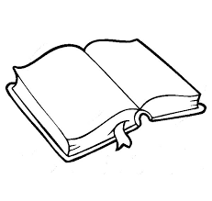(06)**Fill in the blanks using this or that.**

1. ……………….......…………. is a book.



1. ………………………..is a tree.



1. ........................................ is a house.

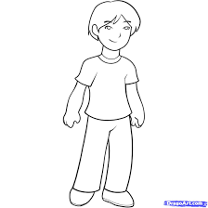

1. 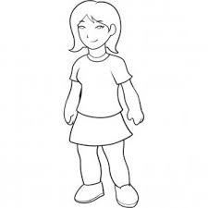.....................................is a boy.
2. ..................................... is a girl.

(15 Marks)

(07)**Match.**



Running

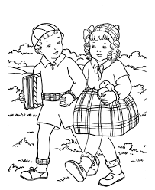

Playing

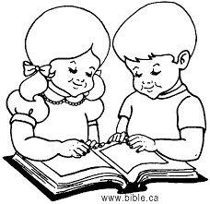

Talking

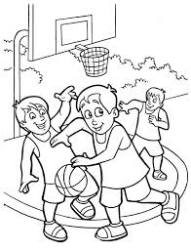

Reading

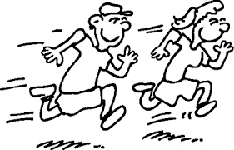

Walking

(10 Marks)

(08)**Write 5 sentences on one of the following topics.**

1. Birds
2. Tree
3. My Father

.....................................................................

1. ............................................................................................................................
2. ............................................................................................................................
3. ............................................................................................................................
4. ............................................................................................................................
5. ............................................................................................................................

(15 Marks)