**St**

**GRADE 2E ST. PETER’S COLLEGE COLOMBO – 04 01 HOUR**

**SECOND TERM TEST – 2016**

**MATHEMATICS**

**NAME:…………………………..……………....CLASS:………..NO:………**

**(01**)I.Count and write the number.

II. **Draw fifteen oranges.**

(15Marks)

(02) **Complete the patterns.**

1. ...................



..............................

2. 2 , 4 , 6 , 8 , ...........................
3. 1 , 2 , 3 , 1 , 2 , .......................
4. 1 , 3 , 5 , 7 , ............................

(10Marks)

(03) **Answer the following questions according to the given price list.**

|  |  |
| --- | --- |
| Item | Price |
| Toffee | One rupee |
| Eraser | 50 cent |
| Guava | Two rupees |
| Ball | Five rupees |
| Apple | 10 rupees |

1. What is the price of an apple? .....................................
2. What is the coin you need to buy a toffee? ...............................
3. What is the price of a ball? ...........................................
4. What is the coin you need to buy an eraser?......................................

(10Marks)

(04) I. **Answer the following questions..**

Tin

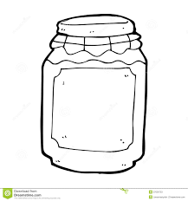

Jam Bottle

1. How many cups of water does the jam bottle hold?.........................
2. How many cups of water does the tin hold?..............................
3. Which container hold the more water?.......................................

(6Marks)

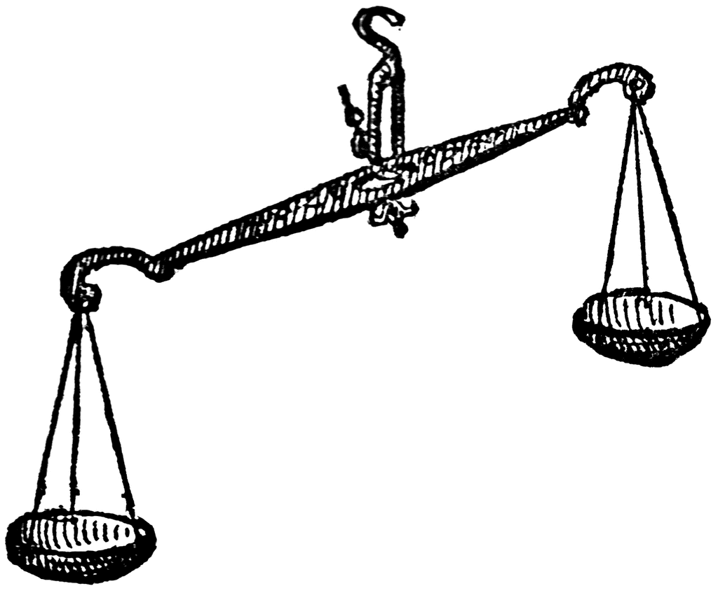II. 1) **Underline the side which shows more weight.**

2) **Circle the light object.**

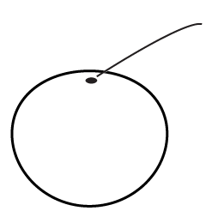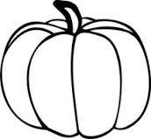

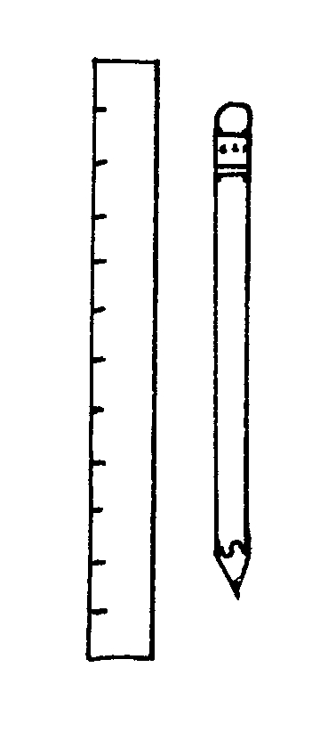 Pumpkin Orange

(2Marks)

III. **Number the pencil from the shortest to the longest.**

1

(2 Marks)

(05) **Fill in the blanks.**

|  |  |  |  |
| --- | --- | --- | --- |
|  | Tens | Units | Number |
|  | 3 | ............... | .............. |
|  | .............. | 5 | .............. |
|  | ............. | .............. | 49 |
|  | ............. | 2 | .............. |
|  | 5 | .............. | ............... |

(10 Marks)

(06)**Under line the correct answer.**

1. The object which can be roll.

(Sphere, Cube, Cuboid)

1. The shape with 4 equal sides and 4 corners.

(Rectangle, Triangle, Square)

1. An object that has a shape of a cuboid.

(Ball, Brick, Pyramid)

1. We go to school in the ,

(morning, afternoon, evening)

1. We see the (Sun, Moon) in the night sky.

(5Marks)

(07**) Write in words.**

1. 10 –
2. 54 –
3. 23 –
4. 75 –
5. 100 – (10Marks)

(08) **Write in numearls**.

1. Five -

2)Twenty -

3)Ninety seven -

4)Sixty eight -

5)Thirty three -

(10Marks)

**(09)Write the correct answer in the box.**

1. 16 – 4 =
2. 20 – 6 =
3. 15 - = 10
4. 8 - = 4
5. 18 - = 9 (10 Marks)

(10) **Add**.

1. 15 + 4 =
2. 12 + 8 =
3. 5 + 3 =
4. 10 + 5 =
5. 8 + 2 =

(10 Marks)